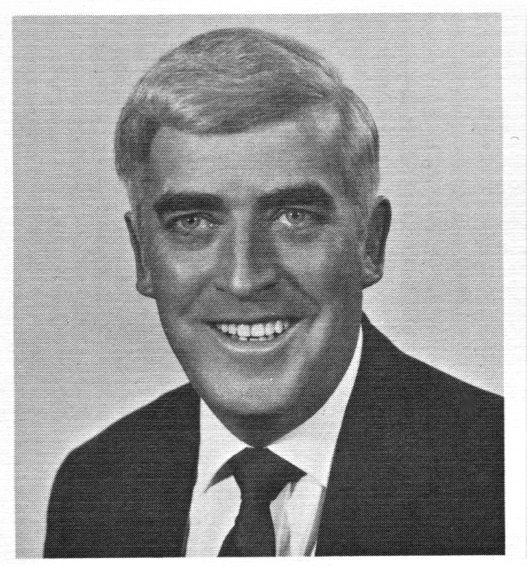

June 28, 1940 -- February 28, 2017

It is profound sadness that we announce the passing of

Past Branch #34 President

and former NALC National Director of Life Insurance

Michael J. O’Connor.

*Mike began his postal career in 1969 and was first elected as Branch #34 Secretary Treasurer in 1975 and later, Branch President in 1979, a position he held for 14-years until he was appointed by then NALC President Vince Sombrotto to serve as National Assistant Secretary Treasurer in January of 1994. Following that appointment, Mike O’Connor represented the interests of Letter Carriers on the national front in various roles including NALC National Secretary-Treasurer and Director of Life Insurance until his retirement in 2002.*

***Boston Branch #34 and NALC Members across the country***

***lost a true friend of Letter Carriers. RIP Brother O’Connor***