**Robber steals mail carrier’s master key in Mattapan, USPS offering $150K reward**

By[**Ted Daniel, Boston 25 News**](https://www.boston25news.com/author/ted-daniel/)October 24, 2023 at 6:23 pm EDT

**NOW PLAYING ABOVE**

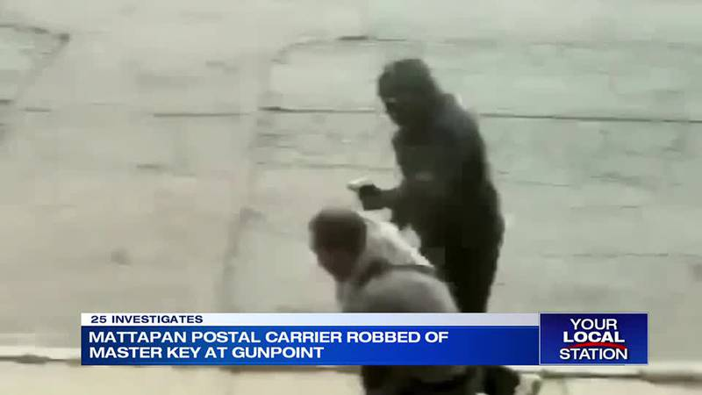

BOSTON — 25 Investigates has learned the United States Postal Service (USPS) is searching for a masked man who allegedly robbed a mail carrier at gunpoint — getting away with the victim’s master key.

That’s according to a copy of a police report and video obtained this week by 25 Investigates.

Officers responded to the Wednesday, October 18 armed robbery at 15 Stonecrest Road in Mattapan and spoke with the victim, who was wearing a USPS uniform at the time.

The victim said while he was delivering mail an unidentified suspect approached him from behind, grabbed the back of his neck, pointed a firearm at his head, and demanded: “just give me the... key.”

The master key can open the USPS large blue mail drop-off boxes: from open collection boxes to outdoor parcel lockers, to cluster box units, to apartment panels.

The masked man made off with the master key and a handheld label-scanning device, police say.

The letter carrier wasn’t physically hurt in the robbery, according to the police report.

The USPS is offering a reward of up to $150,000 for information leading to the arrest and conviction of this robber.

The USPS also made us aware of another postal worker robbery from late last month — it happened shortly before noon in the area of Whitfield Road in Dorchester on September 22.

There’s a similar reward for information leading to a conviction in that case.

25 Investigates has been telling you about these robberies for more than a year now.

Robberies of postal carriers jumped 78 percent last year to nearly 500 nationwide, according to USPS.

25 investigates has told you about six in Boston since 2022.

Criminals target letter carriers to get their master or “arrow keys”.

When one is taken — it can lead to a spike in checks, credit cards, and gifts stolen from the mail.

In a statement, a spokesperson for the USPS said postal robberies carry severe penalties — federal prison terms of up to 25 years for armed robbery of a postal employee or Post Office.